SSSP Problem

Problem :

Develop an application in your favorite programming language.

Make a user input a graph G(V,E). How will a user input graph? (Depends on you).

Use adjacency list to store graph.

Weight of edges should be integers.

Run any SSSP algorithm to know distance of any vertex from any S (source vertex) specified by user.

Solution :

I have used “**Python**” to develop this application program, I used ‘**List**’ and ‘**Dictionary**’ data structure to store the graph as adjacency list.

Here, I’m pasting screen-shot of my **Source-Code**, **Inputs** and it’s **Execution**.

[Source-Code]

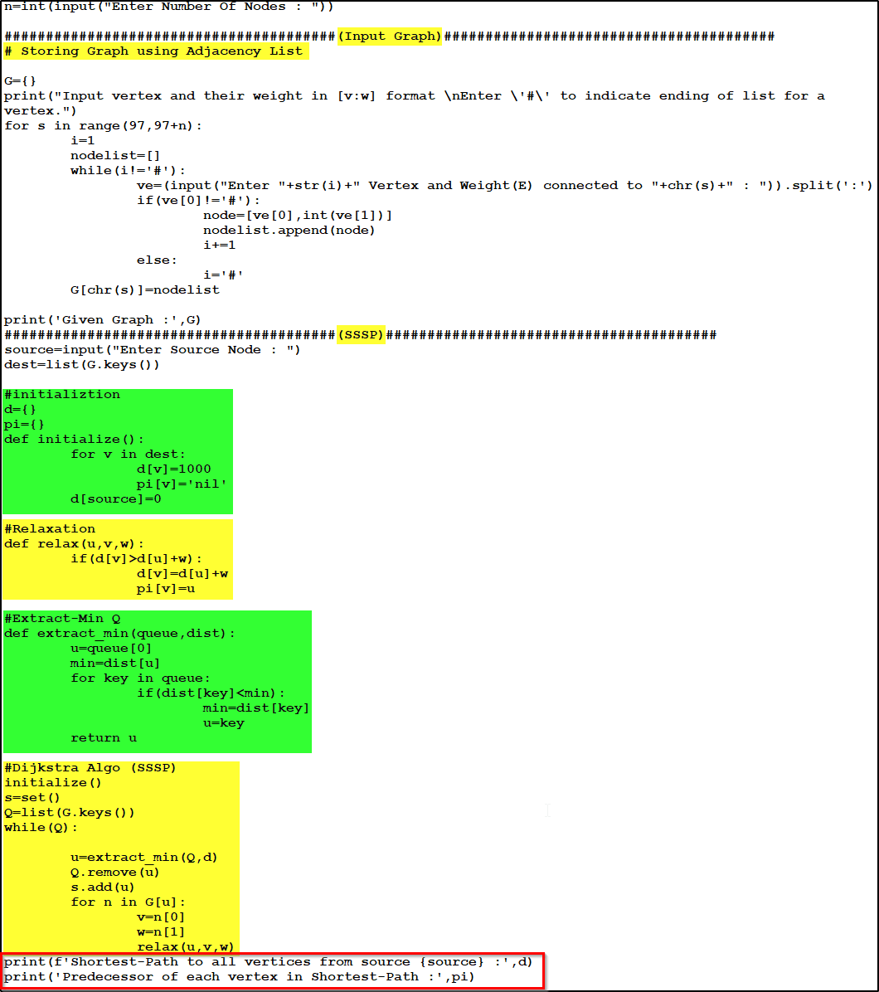

[Inputs]

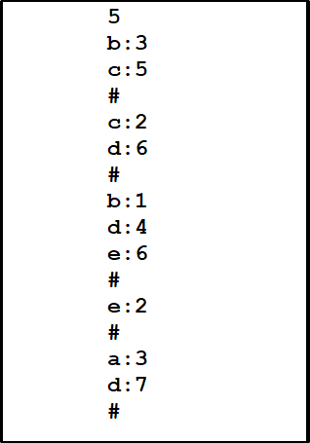

[Execution Of Program]

